

**本科生实验报告**

**实验课程 嵌入式系统设计**

**学院名称 核技术与自动化工程学院**

**专业名称 测控技术与仪器**

**学生姓名 追梦少年南南**

**学生学号 202006010336**

**指导教师 王敏**

**实验地点 6C701**

**实验成绩**

**二〇二二 年 十一 月 二〇二三 年 一 月**

**填写说明**

1. 适用于本科生所有的实验报告（印制实验报告册除外）；
2. 专业填写为专业全称，有专业方向的用小括号标明；
3. 格式要求：
4. 用A4纸双面打印（封面双面打印）或在A4大小纸上用蓝黑色水笔书写。
5. 打印排版：正文用宋体小四号，1.5倍行距，页边距采取默认形式（上下2.54cm，左右2.54cm，页眉1.5cm，页脚1.75cm）。字符间距为默认值（缩放100%，间距：标准）；页码用小五号字底端居中。
6. 具体要求：

**题目**（二号黑体居中）；

**摘要**（“摘要”二字用小二号黑体居中，隔行书写摘要的文字部分，小4号宋体）；

**关键词**（隔行顶格书写“关键词”三字，提炼3-5个关键词，用分号隔开，小4号黑体)；

正文部分采用三级标题；

**第1章** ××(小二号黑体居中，段前0.5行)

**1.1** ×××××小三号黑体×××××（段前、段后0.5行）

**1.1.1**小四号黑体（段前、段后0.5行）

**参考文献**（黑体小二号居中，段前0.5行），参考文献用五号宋体，参照《参考文献著录规则（GB/T 7714－2005）》。

**实验一 呼吸灯的实现**

**一．实验要求**

使用定时器的PWM功能，输出占空比可变的PWM波，用来驱动LED灯，从而达到LED亮度由暗变亮，又由亮变暗的循环。

**二．实验目的**

熟练掌握定时器和PWM的工作原理及寄存器配置方法。

**三．实验内容及步骤**

基础内容：

1、实验工程的建立；

2、GPIO管脚的寄存器配置；

3、定时器寄存器的配置；

4、PWM寄存器的配置；

5、程序功能的实现。

提升内容：

使用按键，以外部中断方式控制LED0呼吸周期。

**四．硬件结构电路图**

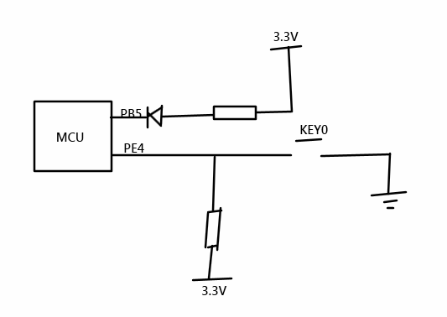

**五．实验设备**

硬件部分：计算机、STM32实验板。

软件部分：计算机windows系统；CubeIDE软件。

**六．实验程序**

**1、给出主程序的流程图：**

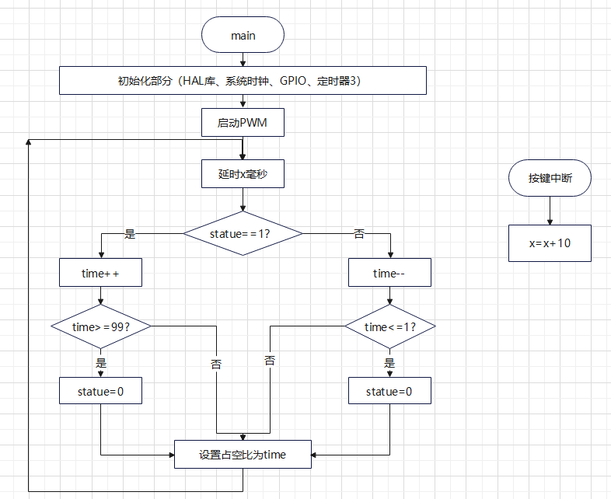

**2、程序代码：**

**（1）时钟配置：**

1. void SystemClock_Config(void)

2. {

3. RCC_OscInitTypeDef RCC_OscInitStruct = {0};

4. RCC_ClkInitTypeDef RCC_ClkInitStruct = {0};

5.

6. /** Initializes the RCC Oscillators according to the specified parameters

7. * in the RCC_OscInitTypeDef structure.

8. */

9. RCC_OscInitStruct.OscillatorType = RCC_OSCILLATORTYPE_HSE;

10. RCC_OscInitStruct.HSEState = RCC_HSE_ON;

11. RCC_OscInitStruct.HSEPredivValue = RCC_HSE_PREDIV_DIV1;

12. RCC_OscInitStruct.HSIState = RCC_HSI_ON;

13. RCC_OscInitStruct.PLL.PLLState = RCC_PLL_ON;

14. RCC_OscInitStruct.PLL.PLLSource = RCC_PLLSOURCE_HSE;

15. RCC_OscInitStruct.PLL.PLLMUL = RCC_PLL_MUL9;

16. if (HAL_RCC_OscConfig(&RCC_OscInitStruct) != HAL_OK)

17. {

18. Error_Handler();

19. }

20.

21. /** Initializes the CPU, AHB and APB buses clocks

22. */

23. RCC_ClkInitStruct.ClockType = RCC_CLOCKTYPE_HCLK|RCC_CLOCKTYPE_SYSCLK

24. |RCC_CLOCKTYPE_PCLK1|RCC_CLOCKTYPE_PCLK2;

25. RCC_ClkInitStruct.SYSCLKSource = RCC_SYSCLKSOURCE_PLLCLK;

26. RCC_ClkInitStruct.AHBCLKDivider = RCC_SYSCLK_DIV1;

27. RCC_ClkInitStruct.APB1CLKDivider = RCC_HCLK_DIV2;

28. RCC_ClkInitStruct.APB2CLKDivider = RCC_HCLK_DIV1;

29.

30. if (HAL_RCC_ClockConfig(&RCC_ClkInitStruct, FLASH_LATENCY_2) != HAL_OK)

31. {

32. Error_Handler();

33. }

34. }

35.

**（2）按键和LED端口的配置：**

按键：

1. void MX_GPIO_Init(void)

2. {

3.

4. GPIO_InitTypeDef GPIO_InitStruct = {0};

5.

6. /* GPIO Ports Clock Enable */

7. __HAL_RCC_GPIOE_CLK_ENABLE();

8. __HAL_RCC_GPIOC_CLK_ENABLE();

9. __HAL_RCC_GPIOA_CLK_ENABLE();

10. __HAL_RCC_GPIOB_CLK_ENABLE();

11.

12. /*Configure GPIO pin : PE4 */

13. GPIO_InitStruct.Pin = GPIO_PIN_4;

14. GPIO_InitStruct.Mode = GPIO_MODE_IT_FALLING;

15. GPIO_InitStruct.Pull = GPIO_PULLUP;

16. HAL_GPIO_Init(GPIOE, &GPIO_InitStruct);

17.

18. /* EXTI interrupt init*/

19. HAL_NVIC_SetPriority(EXTI4_IRQn, 1, 0);

20. HAL_NVIC_EnableIRQ(EXTI4_IRQn);

21.

22. }

23.

LED：

1. void HAL_TIM_MspPostInit(TIM_HandleTypeDef* timHandle)

2. {

3.

4. GPIO_InitTypeDef GPIO_InitStruct = {0};

5. if(timHandle->Instance==TIM3)

6. {

7. /* USER CODE BEGIN TIM3_MspPostInit 0 */

8.

9. /* USER CODE END TIM3_MspPostInit 0 */

10.

11. __HAL_RCC_GPIOB_CLK_ENABLE();

12. /**TIM3 GPIO Configuration

13. PB5 ------> TIM3_CH2

14. */

15. GPIO_InitStruct.Pin = GPIO_PIN_5;

16. GPIO_InitStruct.Mode = GPIO_MODE_AF_PP;

17. GPIO_InitStruct.Speed = GPIO_SPEED_FREQ_LOW;

18. HAL_GPIO_Init(GPIOB, &GPIO_InitStruct);

19.

20. __HAL_AFIO_REMAP_TIM3_PARTIAL();

21.

22. /* USER CODE BEGIN TIM3_MspPostInit 1 */

23.

24. /* USER CODE END TIM3_MspPostInit 1 */

25. }

26.

27. }

28.

**（3）定时器配置：**

1. void MX_TIM3_Init(void)

2. {

3.

4. /* USER CODE BEGIN TIM3_Init 0 */

5.

6. /* USER CODE END TIM3_Init 0 */

7.

8. TIM_MasterConfigTypeDef sMasterConfig = {0};

9. TIM_OC_InitTypeDef sConfigOC = {0};

10.

11. /* USER CODE BEGIN TIM3_Init 1 */

12.

13. /* USER CODE END TIM3_Init 1 */

14. htim3.Instance = TIM3;

15. htim3.Init.Prescaler = 7199;

16. htim3.Init.CounterMode = TIM_COUNTERMODE_UP;

17. htim3.Init.Period = 99;

18. htim3.Init.ClockDivision = TIM_CLOCKDIVISION_DIV1;

19. htim3.Init.AutoReloadPreload = TIM_AUTORELOAD_PRELOAD_DISABLE;

20. if (HAL_TIM_PWM_Init(&htim3) != HAL_OK)

21. {

22. Error_Handler();

23. }

24. sMasterConfig.MasterOutputTrigger = TIM_TRGO_RESET;

25. sMasterConfig.MasterSlaveMode = TIM_MASTERSLAVEMODE_DISABLE;

26. if (HAL_TIMEx_MasterConfigSynchronization(&htim3, &sMasterConfig) != HAL_OK)

27. {

28. Error_Handler();

29. }

30. sConfigOC.OCMode = TIM_OCMODE_PWM1;

31. sConfigOC.Pulse = 0;

32. sConfigOC.OCPolarity = TIM_OCPOLARITY_HIGH;

33. sConfigOC.OCFastMode = TIM_OCFAST_DISABLE;

34. if (HAL_TIM_PWM_ConfigChannel(&htim3, &sConfigOC, TIM_CHANNEL_2) != HAL_OK)

35. {

36. Error_Handler();

37. }

38. /* USER CODE BEGIN TIM3_Init 2 */

39.

40. /* USER CODE END TIM3_Init 2 */

41. HAL_TIM_MspPostInit(&htim3);

42.

43. }

**（4）PWM的配置：**

1. HAL_StatusTypeDef HAL_TIM_PWM_Start(TIM_HandleTypeDef *htim, uint32_t Channel)

2. {

3. uint32_t tmpsmcr;

4.

5. /* Check the parameters */

6. assert_param(IS_TIM_CCX_INSTANCE(htim->Instance, Channel));

7.

8. /* Check the TIM channel state */

9. if (TIM_CHANNEL_STATE_GET(htim, Channel) != HAL_TIM_CHANNEL_STATE_READY)

10. {

11. return HAL_ERROR;

12. }

13.

14. /* Set the TIM channel state */

15. TIM_CHANNEL_STATE_SET(htim, Channel, HAL_TIM_CHANNEL_STATE_BUSY);

16.

17. /* Enable the Capture compare channel */

18. TIM_CCxChannelCmd(htim->Instance, Channel, TIM_CCx_ENABLE);

19.

20. if (IS_TIM_BREAK_INSTANCE(htim->Instance) != RESET)

21. {

22. /* Enable the main output */

23. __HAL_TIM_MOE_ENABLE(htim);

24. }

25.

26. /* Enable the Peripheral, except in trigger mode where enable is automatically done with trigger */

27. if (IS_TIM_SLAVE_INSTANCE(htim->Instance))

28. {

29. tmpsmcr = htim->Instance->SMCR & TIM_SMCR_SMS;

30. if (!IS_TIM_SLAVEMODE_TRIGGER_ENABLED(tmpsmcr))

31. {

32. __HAL_TIM_ENABLE(htim);

33. }

34. }

35. else

36. {

37. __HAL_TIM_ENABLE(htim);

38. }

39.

40. /* Return function status */

41. return HAL_OK;

42. }

43.

**（5）ｍａｉｎ函数：**

1. uint8_t x=10;//全局变量，用于控制时间

1. void HAL_GPIO_EXTI_Callback(uint16_t GPIO_Pin)//中断回调函数，每按一次按键都要加10ms

2. {

3. if (GPIO_Pin == GPIO_PIN_4)

4. {

5. x=x+10;

6. }

7. }

1. int main(void)

2. {

3. HAL_Init();

4. SystemClock_Config();

5. MX_GPIO_Init();

6. MX_TIM3_Init();

7. HAL_TIM_PWM_Start(&htim3, TIM_CHANNEL_2);

8. uint8_t time=0;

9. uint8_t statue=0;

10. while (1)

11. {

12. __HAL_TIM_SetCompare(&htim3, TIM_CHANNEL_2, time);

13. HAL_Delay(x);

14. switch(statue)

15. {

16. case 0:

17. if(++time>=99)

18. {

19. statue=1;

20. }

21. break;

22. case 1:

23. if(--time<=1)

24. {

25. statue=0;

26. }

27. break;

28. }

29. }

30. }

31.

**六．程序调试及实验结果**

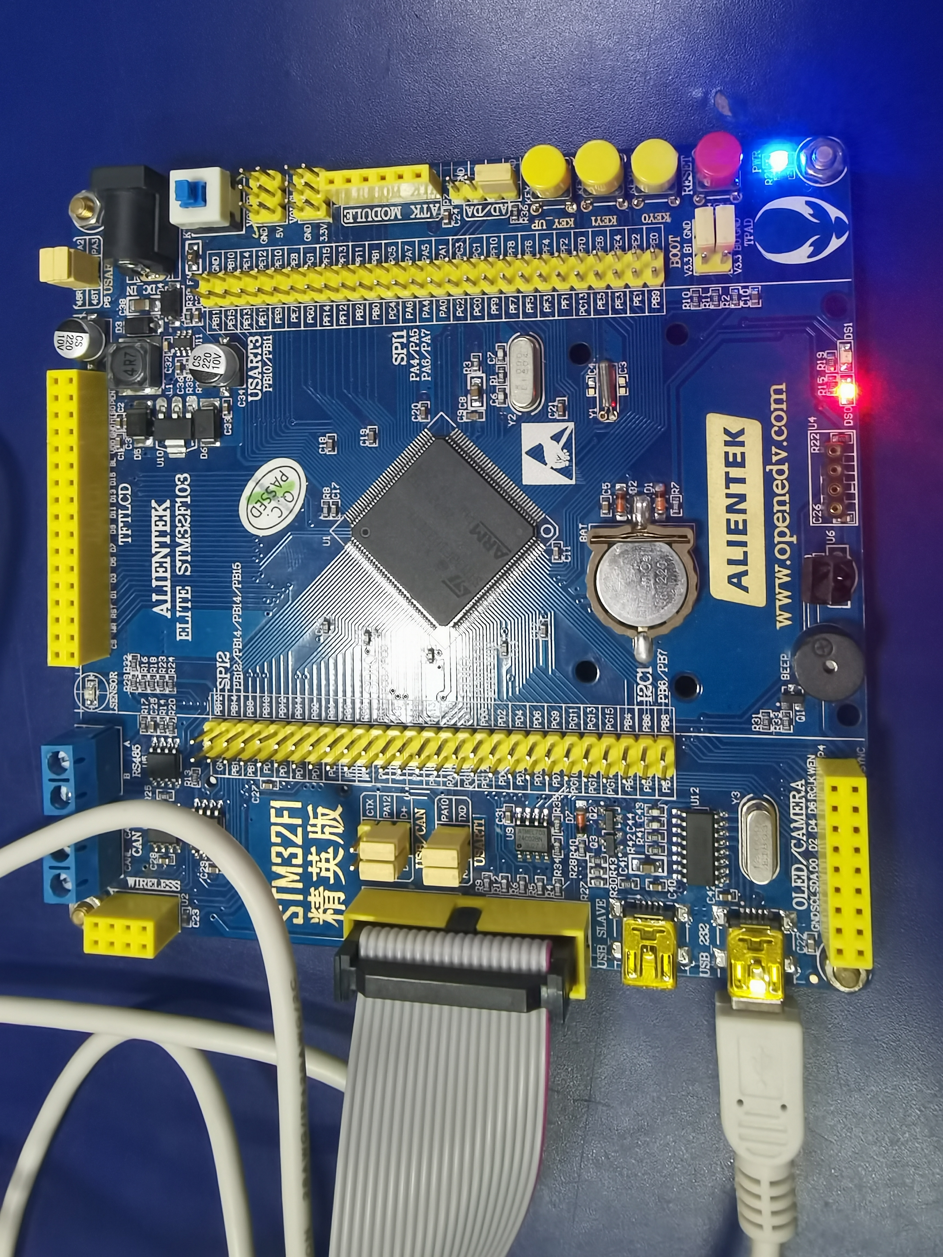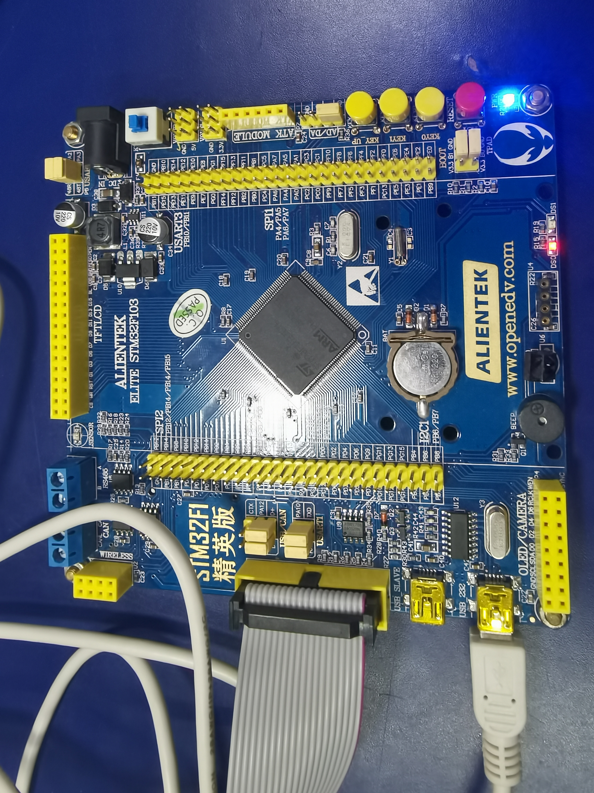

左图与右图之间灯的亮灭有明显不同，按下按键后时间有明显延长。

注意事项：无

**实验二 简易电压表的实现**

**一．实验要求**

将ADC采集的电压数据，通过DMA方式传送到存储器中，并将转换后的电压值通过串口助手显示。每秒刷新一次数据。

**二．实验目的**

掌握ADC、串口通信的工作原理及程序编写。

**三．实验内容及步骤（提升内容选做）**

基础内容：

1、使用ADC采集电压数据；

2、将ADC采集的数据由串口传送到PC机；

3、通过串口助手显示出ADC的电压；

提升内容：

1、将ADC采集的数据通过DMA方式传送到存储器；

2、在基础要求上加入LCD屏上进行电压值显示；

3、对ADC采样数据进行平滑滤波处理（均值滤波），以减小误差。

**四．硬件结构电路图**

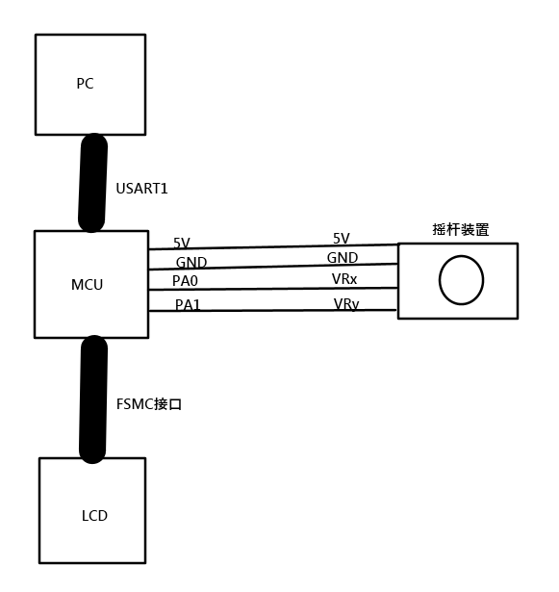

**五．实验设备**

1、硬件部分：计算机、STM32实验板。

2、软件部分：计算机windows系统；CubeIDE软件

**六．实验程序**

**1、给出主程序的流程图：**

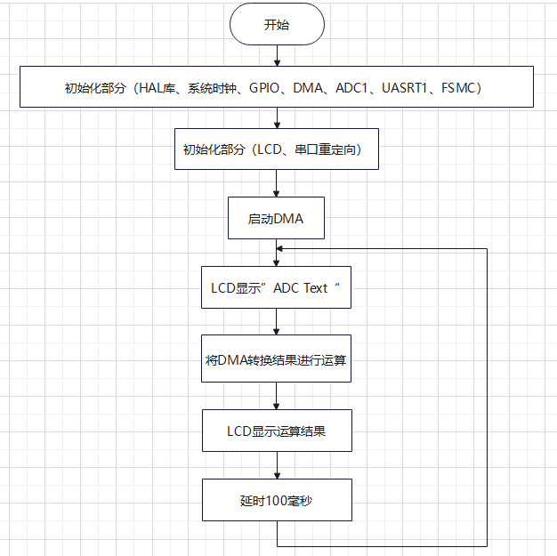

**2、程序代码：**

**（1）ADC配置**

1. void MX_ADC1_Init(void)

2. {

3. ADC_ChannelConfTypeDef sConfig = {0};

4. hadc1.Instance = ADC1;

5. hadc1.Init.ScanConvMode = ADC_SCAN_ENABLE;

6. hadc1.Init.ContinuousConvMode = ENABLE;

7. hadc1.Init.DiscontinuousConvMode = DISABLE;

8. hadc1.Init.ExternalTrigConv = ADC_SOFTWARE_START;

9. hadc1.Init.DataAlign = ADC_DATAALIGN_RIGHT;

10. hadc1.Init.NbrOfConversion = 2;

11. if (HAL_ADC_Init(&hadc1) != HAL_OK)

12. {

13. Error_Handler();

14. }

15. sConfig.Channel = ADC_CHANNEL_0;

16. sConfig.Rank = ADC_REGULAR_RANK_1;

17. sConfig.SamplingTime = ADC_SAMPLETIME_13CYCLES_5;

18. if (HAL_ADC_ConfigChannel(&hadc1, &sConfig) != HAL_OK)

19. {

20. Error_Handler();

21. }

22. sConfig.Channel = ADC_CHANNEL_1;

23. sConfig.Rank = ADC_REGULAR_RANK_2;

24. if (HAL_ADC_ConfigChannel(&hadc1, &sConfig) != HAL_OK)

25. {

26. Error_Handler();

27. }

28. }

29.

**（2）DMA配置**

1. void MX_DMA_Init(void)

2. {

3. __HAL_RCC_DMA1_CLK_ENABLE()

4. }

**经过多次尝试，如果选择开启DMA中断会导致程序卡死，取消使能中断后生效。**

**（3）串口配置**

1. void MX_USART1_UART_Init(void)

2. {

3. huart1.Instance = USART1;

4. huart1.Init.BaudRate = 115200;

5. huart1.Init.WordLength = UART_WORDLENGTH_8B;

6. huart1.Init.StopBits = UART_STOPBITS_1;

7. huart1.Init.Parity = UART_PARITY_NONE;

8. huart1.Init.Mode = UART_MODE_TX_RX;

9. huart1.Init.HwFlowCtl = UART_HWCONTROL_NONE;

10. huart1.Init.OverSampling = UART_OVERSAMPLING_16;

11. if (HAL_UART_Init(&huart1) != HAL_OK)

12. {

13. Error_Handler();

14. }

15.

16. }

17.

1. void HAL_UART_MspInit(UART_HandleTypeDef* uartHandle)

2. {

3. GPIO_InitTypeDef GPIO_InitStruct = {0};

4. if(uartHandle->Instance==USART1)

5. {

6. __HAL_RCC_USART1_CLK_ENABLE();

7. __HAL_RCC_GPIOA_CLK_ENABLE();

8. GPIO_InitStruct.Pin = GPIO_PIN_9;

9. GPIO_InitStruct.Mode = GPIO_MODE_AF_PP;

10. GPIO_InitStruct.Speed = GPIO_SPEED_FREQ_HIGH;

11. HAL_GPIO_Init(GPIOA, &GPIO_InitStruct);

12. GPIO_InitStruct.Pin = GPIO_PIN_10;

13. GPIO_InitStruct.Mode = GPIO_MODE_INPUT;

14. GPIO_InitStruct.Pull = GPIO_NOPULL;

15. HAL_GPIO_Init(GPIOA, &GPIO_InitStruct);

16. HAL_NVIC_SetPriority(USART1_IRQn, 0, 0);

17. HAL_NVIC_EnableIRQ(USART1_IRQn);

18. }

19. }

20.

**（4）LCD配置**

**FSMC配置：**

1. void MX_FSMC_Init(void)

2. {

3. FSMC_NORSRAM_TimingTypeDef Timing = {0};

4. FSMC_NORSRAM_TimingTypeDef ExtTiming = {0};

5. hsram4.Instance = FSMC_NORSRAM_DEVICE;

6. hsram4.Extended = FSMC_NORSRAM_EXTENDED_DEVICE;

7. /* hsram4.Init */

8. hsram4.Init.NSBank = FSMC_NORSRAM_BANK4;

9. hsram4.Init.DataAddressMux = FSMC_DATA_ADDRESS_MUX_DISABLE;

10. hsram4.Init.MemoryType = FSMC_MEMORY_TYPE_SRAM;

11. hsram4.Init.MemoryDataWidth = FSMC_NORSRAM_MEM_BUS_WIDTH_16;

12. hsram4.Init.BurstAccessMode = FSMC_BURST_ACCESS_MODE_DISABLE;

13. hsram4.Init.WaitSignalPolarity = FSMC_WAIT_SIGNAL_POLARITY_LOW;

14. hsram4.Init.WrapMode = FSMC_WRAP_MODE_DISABLE;

15. hsram4.Init.WaitSignalActive = FSMC_WAIT_TIMING_BEFORE_WS;

16. hsram4.Init.WriteOperation = FSMC_WRITE_OPERATION_ENABLE;

17. hsram4.Init.WaitSignal = FSMC_WAIT_SIGNAL_DISABLE;

18. hsram4.Init.ExtendedMode = FSMC_EXTENDED_MODE_ENABLE;

19. hsram4.Init.AsynchronousWait = FSMC_ASYNCHRONOUS_WAIT_DISABLE;

20. hsram4.Init.WriteBurst = FSMC_WRITE_BURST_DISABLE;

21. /* Timing */

22. Timing.AddressSetupTime = 2;

23. Timing.AddressHoldTime = 15;

24. Timing.DataSetupTime = 16;

25. Timing.BusTurnAroundDuration = 0;

26. Timing.CLKDivision = 16;

27. Timing.DataLatency = 17;

28. Timing.AccessMode = FSMC_ACCESS_MODE_A;

29. /* ExtTiming */

30. ExtTiming.AddressSetupTime = 4;

31. ExtTiming.AddressHoldTime = 15;

32. ExtTiming.DataSetupTime = 9;

33. ExtTiming.BusTurnAroundDuration = 0;

34. ExtTiming.CLKDivision = 16;

35. ExtTiming.DataLatency = 17;

36. ExtTiming.AccessMode = FSMC_ACCESS_MODE_A;

37. if (HAL_SRAM_Init(&hsram4, &Timing, &ExtTiming) != HAL_OK)

38. {

39. Error_Handler( );

40. }

41. __HAL_AFIO_FSMCNADV_DISCONNECTED();

42. }

43. static uint32_t FSMC_Initialized = 0;

44. static void HAL_FSMC_MspInit(void){

45. GPIO_InitTypeDef GPIO_InitStruct = {0};

46. if (FSMC_Initialized) {

47. return;

48. }

49. FSMC_Initialized = 1;

50. __HAL_RCC_FSMC_CLK_ENABLE();

51. GPIO_InitStruct.Pin = GPIO_PIN_0|GPIO_PIN_12;

52. GPIO_InitStruct.Mode = GPIO_MODE_AF_PP;

53. GPIO_InitStruct.Speed = GPIO_SPEED_FREQ_HIGH;

54. HAL_GPIO_Init(GPIOG, &GPIO_InitStruct);

55. GPIO_InitStruct.Pin = GPIO_PIN_7|GPIO_PIN_8|GPIO_PIN_9|GPIO_PIN_10

56. |GPIO_PIN_11|GPIO_PIN_12|GPIO_PIN_13|GPIO_PIN_14

57. |GPIO_PIN_15;

58. GPIO_InitStruct.Mode = GPIO_MODE_AF_PP;

59. GPIO_InitStruct.Speed = GPIO_SPEED_FREQ_HIGH;

60. HAL_GPIO_Init(GPIOE, &GPIO_InitStruct);

61. GPIO_InitStruct.Pin = GPIO_PIN_8|GPIO_PIN_9|GPIO_PIN_10|GPIO_PIN_14

62. |GPIO_PIN_15|GPIO_PIN_0|GPIO_PIN_1|GPIO_PIN_4

63. |GPIO_PIN_5;

64. GPIO_InitStruct.Mode = GPIO_MODE_AF_PP;

65. GPIO_InitStruct.Speed = GPIO_SPEED_FREQ_HIGH;

66.

67. HAL_GPIO_Init(GPIOD, &GPIO_InitStruct);

68. }

69.

**LCD驱动移植(原创，追梦少年南南是我的网名)：**

[基于正点原子F103精英板和CubeIDE的Hal库LCD驱动移植（从零开始）_追梦少年南南的博客-CSDN博客_正点原子lcd驱动](https://blog.csdn.net/m0_66415242/article/details/127601015?spm=1001.2014.3001.5502)

**（5）数字滤波**

1. uint32_t Mean_filter(uint32_t* A)//均值滤波

2. {

3. int i=0;

4. uint32_t sum;

5. for(i=0;i<5;i++)

6. {

7. sum+=A[i];

8. }

9. sum=sum/5;

10. return sum;

11. }

12.

**（6）main函数**

1. int main(void)

2. {

3. HAL_Init();

4. SystemClock_Config();

5. MX_GPIO_Init();

6. MX_DMA_Init();

7. MX_ADC1_Init();

8. MX_USART1_UART_Init();

9. MX_FSMC_Init();

10. LCD_Init();

11. LCD_DisplayOn();

12. LCD_Clear(WHITE);

13. HAL_GPIO_WritePin(LCD_BL_GPIO_Port, LCD_BL_Pin, 1);

14. uint32_t val_x=0;

15. uint32_t Volt_x=0;

16. uint32_t Volt_y=0;

17. uint32_t volt_x[5]={0};

18. uint32_t val_y=0;

19. uint32_t volt_y[5]={0};

20. RetargetInit(&huart1);

21. char str_x[50];

22. char str_y[50];

23. HAL_ADC_Start_DMA(&hadc1, dmaBuffer, 2);

24. while (1)

25. {

26. LCD_ShowString(30,110-16,200,16,16,"ADC test:");

27. for(int i=0;i<5;i++)

28. {

29. volt_x[i]=(3300*dmaBuffer[0])>>12;

30. volt_y[i]=(3300*dmaBuffer[1])>>12;

31. }

32. Volt_x=Mean_filter(volt_x);

33. Volt_y=Mean_filter(volt_y);

34. printf("x:%dmv y:%dmv\r\n",Volt_x,Volt_y);

35. sprintf(str_x,"x=%4dmv",Volt_x);

36. sprintf(str_y,"y=%4dmv",Volt_y);

37. LCD_ShowString(30,110,200,16,16,str_x);

38. LCD_ShowString(30,110+16,200,16,16,str_y);

39. HAL_Delay(100);

40. }

41. }

42. void SystemClock_Config(void)

43. {

44. RCC_OscInitTypeDef RCC_OscInitStruct = {0};

45. RCC_ClkInitTypeDef RCC_ClkInitStruct = {0};

46. RCC_PeriphCLKInitTypeDef PeriphClkInit = {0};

47. RCC_OscInitStruct.OscillatorType = RCC_OSCILLATORTYPE_HSI;

48. RCC_OscInitStruct.HSIState = RCC_HSI_ON;

49. RCC_OscInitStruct.HSICalibrationValue = RCC_HSICALIBRATION_DEFAULT;

50. RCC_OscInitStruct.PLL.PLLState = RCC_PLL_ON;

51. RCC_OscInitStruct.PLL.PLLSource = RCC_PLLSOURCE_HSI_DIV2;

52. RCC_OscInitStruct.PLL.PLLMUL = RCC_PLL_MUL4;

53. if (HAL_RCC_OscConfig(&RCC_OscInitStruct) != HAL_OK)

54. {

55. Error_Handler();

56. }

57. RCC_ClkInitStruct.ClockType = RCC_CLOCKTYPE_HCLK|RCC_CLOCKTYPE_SYSCLK

58. |RCC_CLOCKTYPE_PCLK1|RCC_CLOCKTYPE_PCLK2;

59. RCC_ClkInitStruct.SYSCLKSource = RCC_SYSCLKSOURCE_PLLCLK;

60. RCC_ClkInitStruct.AHBCLKDivider = RCC_SYSCLK_DIV1;

61. RCC_ClkInitStruct.APB1CLKDivider = RCC_HCLK_DIV1;

62. RCC_ClkInitStruct.APB2CLKDivider = RCC_HCLK_DIV1;

63.

64. if (HAL_RCC_ClockConfig(&RCC_ClkInitStruct, FLASH_LATENCY_0) != HAL_OK)

65. {

66. Error_Handler();

67. }

68. PeriphClkInit.PeriphClockSelection = RCC_PERIPHCLK_ADC;

69. PeriphClkInit.AdcClockSelection = RCC_ADCPCLK2_DIV2;

70. if (HAL_RCCEx_PeriphCLKConfig(&PeriphClkInit) != HAL_OK)

71. {

72. Error_Handler();

73. }

74. }

75.

**六．程序调试及实验结果**

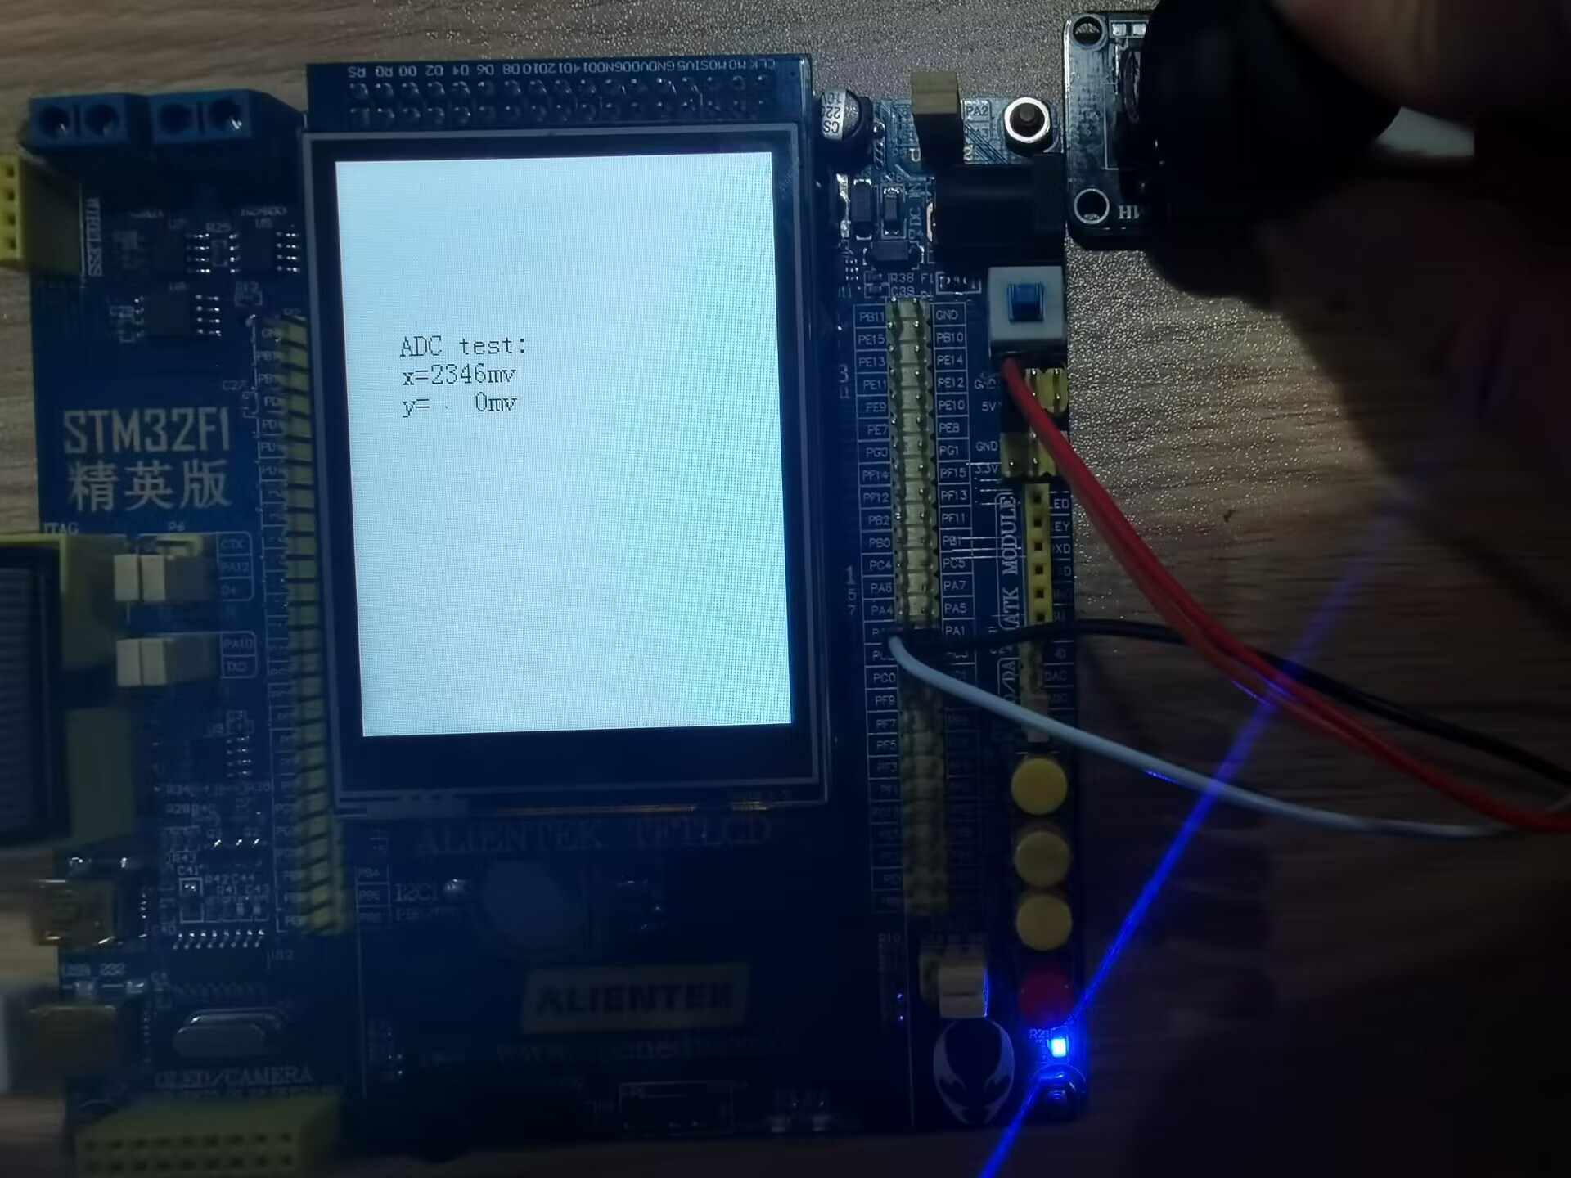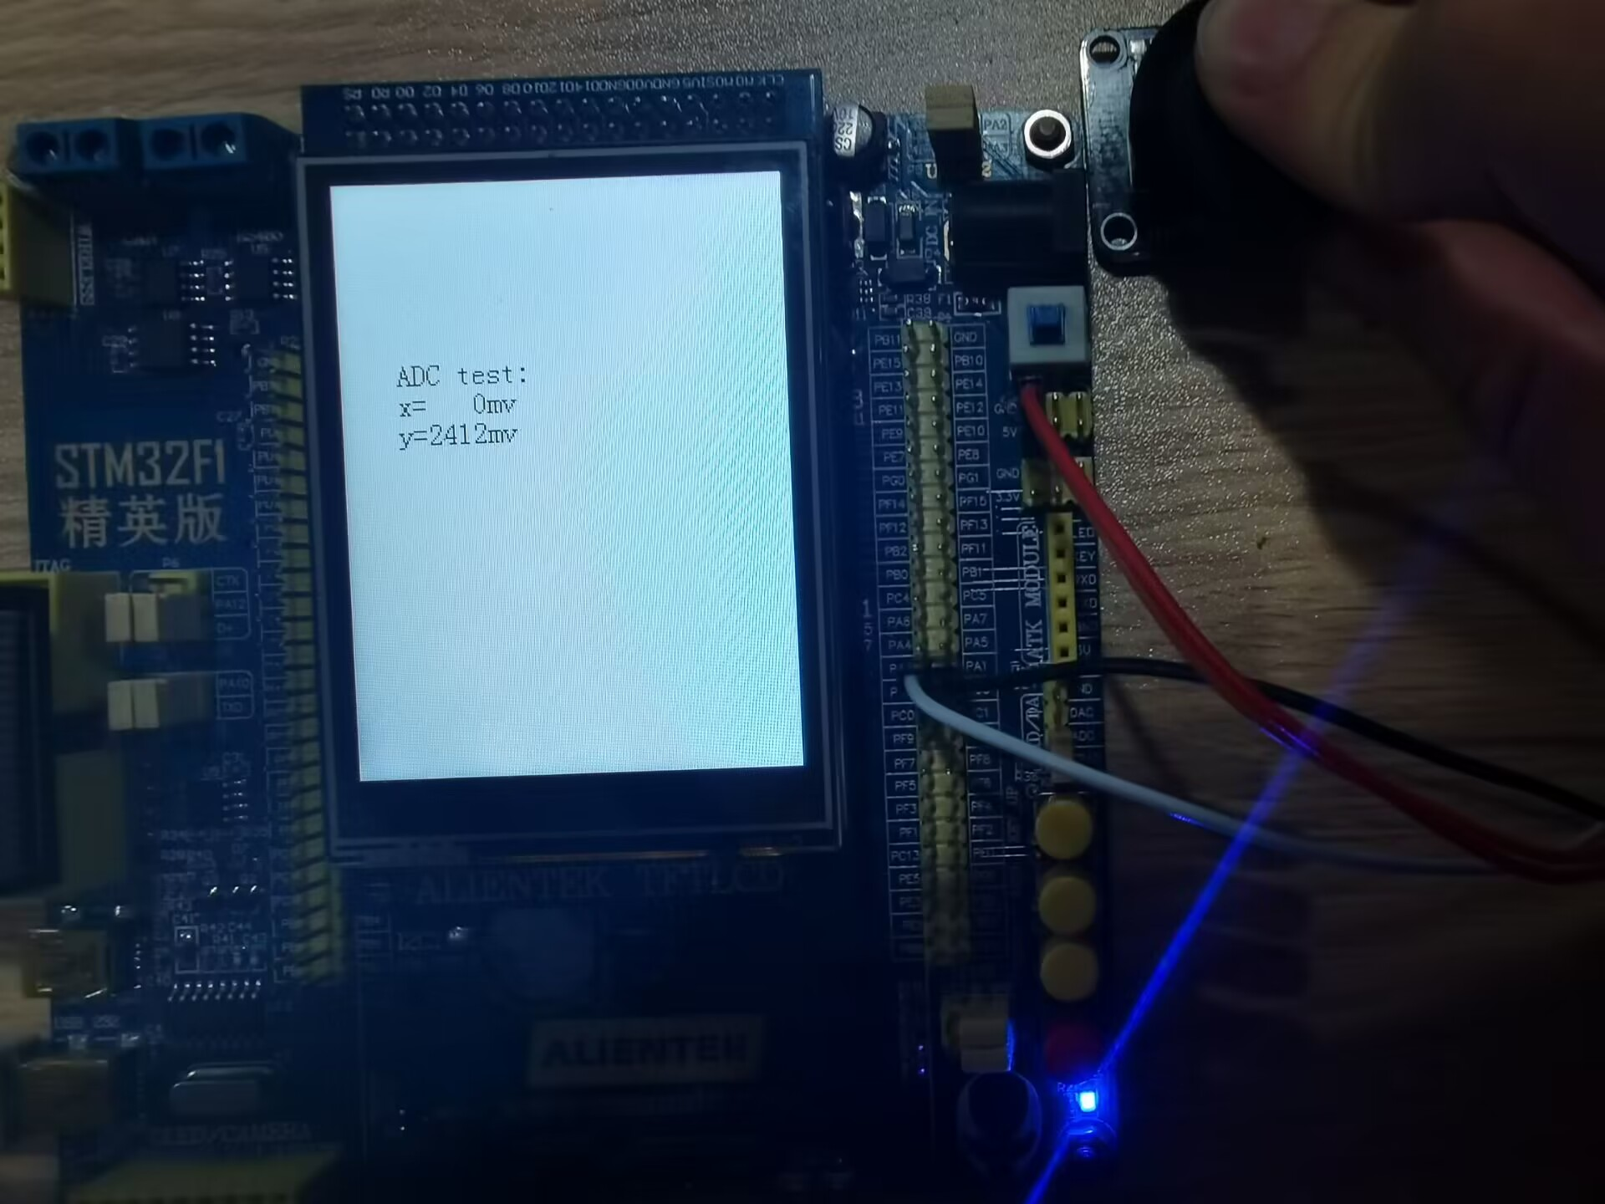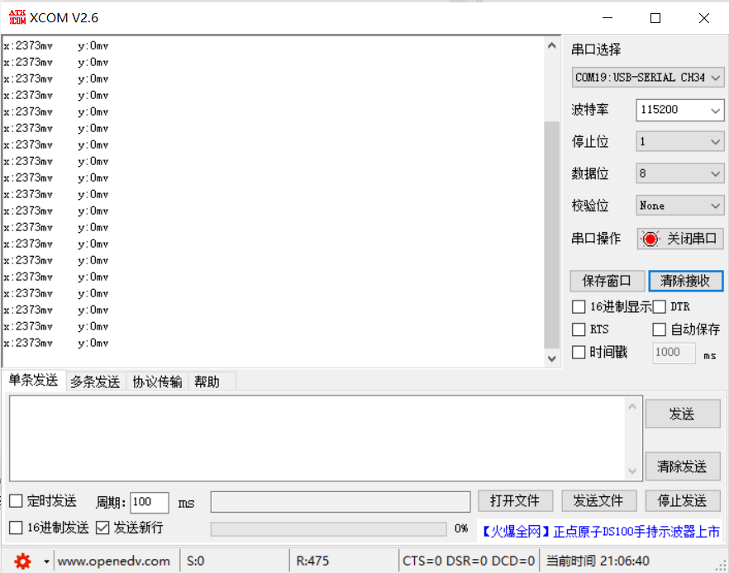

图一是将摇杆y方向推到底，图二是将摇杆x方向推到底。

图三为串口打印。

注意事项：串口重定向用到了retarget.c，为官方提供的代码，初始化之后直接使用即可。

**实验三 简易温度计的实现**

**一．实验要求**

将温度传感器采集的数据，通过单总线将温湿度数据显示在LCD上。

**二．实验目的**

掌握单总线通信原理、通信协议及程序编写。

**三．实验内容及步骤**

1、读取温度传感器的数据；

2、将采集的数据显示在LCD屏上。

**四．硬件结构电路图**

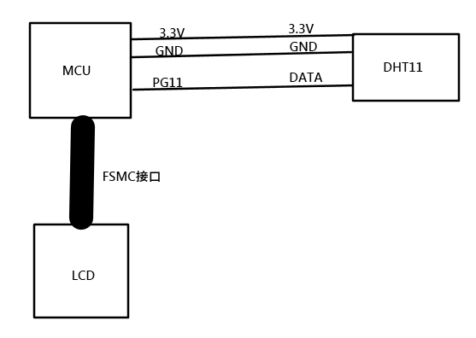

**五．实验设备**

1、硬件部分：计算机、STM32实验板。

2、软件部分：计算机windows系统；CubeIDE软件

**六．实验程序**

**1、给出主程序的流程图：**

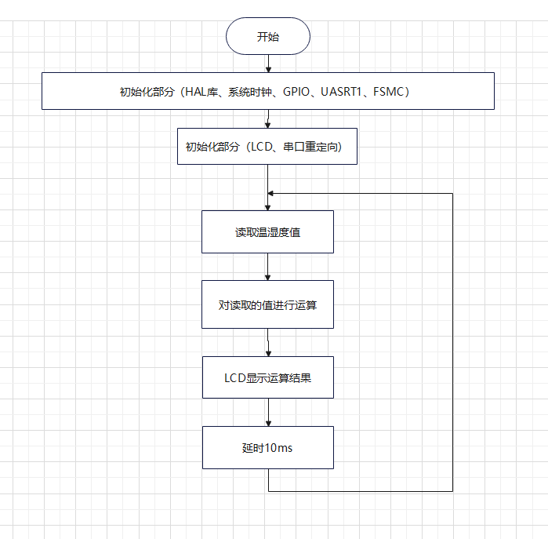

**2、程序代码：**

**（1）时钟配置：**

1. void SystemClock_Config(void)

2. {

3. RCC_OscInitTypeDef RCC_OscInitStruct = {0};

4. RCC_ClkInitTypeDef RCC_ClkInitStruct = {0};

5. RCC_OscInitStruct.OscillatorType = RCC_OSCILLATORTYPE_HSE;

6. RCC_OscInitStruct.HSEState = RCC_HSE_ON;

7. RCC_OscInitStruct.HSEPredivValue = RCC_HSE_PREDIV_DIV1;

8. RCC_OscInitStruct.HSIState = RCC_HSI_ON;

9. RCC_OscInitStruct.PLL.PLLState = RCC_PLL_ON;

10. RCC_OscInitStruct.PLL.PLLSource = RCC_PLLSOURCE_HSE;

11. RCC_OscInitStruct.PLL.PLLMUL = RCC_PLL_MUL9;

12. if (HAL_RCC_OscConfig(&RCC_OscInitStruct) != HAL_OK)

13. {

14. Error_Handler();

15. }

16. RCC_ClkInitStruct.ClockType = RCC_CLOCKTYPE_HCLK|RCC_CLOCKTYPE_SYSCLK

17. |RCC_CLOCKTYPE_PCLK1|RCC_CLOCKTYPE_PCLK2;

18. RCC_ClkInitStruct.SYSCLKSource = RCC_SYSCLKSOURCE_PLLCLK;

19. RCC_ClkInitStruct.AHBCLKDivider = RCC_SYSCLK_DIV1;

20. RCC_ClkInitStruct.APB1CLKDivider = RCC_HCLK_DIV2;

21. RCC_ClkInitStruct.APB2CLKDivider = RCC_HCLK_DIV1;

22.

23. if (HAL_RCC_ClockConfig(&RCC_ClkInitStruct, FLASH_LATENCY_2) != HAL_OK)

24. {

25. Error_Handler();

26. }

27. }

**（2）端口的配置：**

1. void MX_GPIO_Init(void)

2. {

3. GPIO_InitTypeDef GPIO_InitStruct = {0};

4. __HAL_RCC_GPIOC_CLK_ENABLE();

5. __HAL_RCC_GPIOA_CLK_ENABLE();

6. __HAL_RCC_GPIOB_CLK_ENABLE();

7. __HAL_RCC_GPIOG_CLK_ENABLE();

8. __HAL_RCC_GPIOE_CLK_ENABLE();

9. __HAL_RCC_GPIOD_CLK_ENABLE();

10. HAL_GPIO_WritePin(GPIOA, GPIO_PIN_5|GPIO_PIN_7, GPIO_PIN_RESET);

11. HAL_GPIO_WritePin(LCD_BL_GPIO_Port, LCD_BL_Pin, GPIO_PIN_RESET);

12. HAL_GPIO_WritePin(DHT11_GPIO_Port, DHT11_Pin, GPIO_PIN_RESET);

13. GPIO_InitStruct.Pin = GPIO_PIN_5|GPIO_PIN_7;

14. GPIO_InitStruct.Mode = GPIO_MODE_OUTPUT_PP;

15. GPIO_InitStruct.Pull = GPIO_NOPULL;

16. GPIO_InitStruct.Speed = GPIO_SPEED_FREQ_LOW;

17. HAL_GPIO_Init(GPIOA, &GPIO_InitStruct);

18. GPIO_InitStruct.Pin = LCD_BL_Pin;

19. GPIO_InitStruct.Mode = GPIO_MODE_OUTPUT_PP;

20. GPIO_InitStruct.Pull = GPIO_NOPULL;

21. GPIO_InitStruct.Speed = GPIO_SPEED_FREQ_LOW;

22. HAL_GPIO_Init(LCD_BL_GPIO_Port, &GPIO_InitStruct);

23. GPIO_InitStruct.Pin = DHT11_Pin;

24. GPIO_InitStruct.Mode = GPIO_MODE_OUTPUT_PP;

25. GPIO_InitStruct.Pull = GPIO_NOPULL;

26. GPIO_InitStruct.Speed = GPIO_SPEED_FREQ_LOW;

27. HAL_GPIO_Init(DHT11_GPIO_Port, &GPIO_InitStruct);

28.

29. }

**（3）单总线配置及数据读取**

1. #define delay_ms(x) HAL_Delay(x)

2. void delay_us (uint16_t time)

3. {

4. __HAL_TIM_SET_COUNTER(&htim5, 0);

5. while ((__HAL_TIM_GET_COUNTER(&htim5))<time);

6. }

7. void Set_Pin_Output (GPIO_TypeDef *GPIOx, uint16_t GPIO_Pin)

8. {

9. GPIO_InitTypeDef GPIO_InitStruct = {0};

10. GPIO_InitStruct.Pin = GPIO_Pin;

11. GPIO_InitStruct.Mode = GPIO_MODE_OUTPUT_PP;

12. GPIO_InitStruct.Speed = GPIO_SPEED_FREQ_LOW;

13. HAL_GPIO_Init(GPIOx, &GPIO_InitStruct);

14. }

15.

16. void Set_Pin_Input (GPIO_TypeDef *GPIOx, uint16_t GPIO_Pin)

17. {

18. GPIO_InitTypeDef GPIO_InitStruct = {0};

19. GPIO_InitStruct.Pin = GPIO_Pin;

20. GPIO_InitStruct.Mode = GPIO_MODE_INPUT;

21. GPIO_InitStruct.Pull = GPIO_PULLUP;

22. HAL_GPIO_Init(GPIOx, &GPIO_InitStruct);

23. }

24. void DHT11_IO_IN(void)

25. {

26. GPIOG->CRH&=0xffff0fff;

27. GPIOG->CRH|=8<<12;

28. }

29. void DHT11_IO_OUT(void)

30. {

31. GPIOG->CRH&=0XFFFF0FFF;

32. GPIOG->CRH|=3<<12;

33. }

34. //复位DHT11

35. void DHT11_Rst(void)

36. {

37. DHT11_IO_OUT(); //SET OUTPUT

38. HAL_GPIO_WritePin(GPIOG, GPIO_PIN_11, 0);

39. delay_ms(20); //拉低至少18ms

40. HAL_GPIO_WritePin(GPIOG, GPIO_PIN_11, 1);

41. delay_us(30); //主机拉高20~40us

42. }

43. //等待DHT11的回应

44. //返回1:未检测到DHT11的存在

45. //返回0:存在

46. uint8_t DHT11_Check(void)

47. {

48. uint8_t retry=0;

49. DHT11_IO_IN();//SET INPUT

50. while (DHT11_DQ_IN&&retry<100)//DHT11会拉低40~80us

51. {

52. retry++;

53. delay_us(1);

54. };

55. if(retry>=100)return 1;

56. else retry=0;

57. while (!DHT11_DQ_IN&&retry<100)//DHT11拉低后会再次拉高40~80us

58. {

59. retry++;

60. delay_us(1);

61. };

62. if(retry>=100)return 1;

63. return 0;

64. }

65. //从DHT11读取一个位

66. //返回值：1/0

67. uint8_t DHT11_Read_Bit(void)

68. {

69. uint8_t retry=0;

70. while(DHT11_DQ_IN&&retry<100)//等待变为低电平

71. {

72. retry++;

73. delay_us(1);

74. }

75. retry=0;

76. while(!DHT11_DQ_IN&&retry<100)//等待变高电平

77. {

78. retry++;

79. delay_us(1);

80. }

81. delay_us(40);//等待40us

82. if(DHT11_DQ_IN)return 1;

83. else return 0;

84. }

85. //从DHT11读取一个字节

86. //返回值：读到的数据

87. uint8_t DHT11_Read_Byte(void)

88. {

89. uint8_t i,dat;

90. dat=0;

91. for (i=0;i<8;i++)

92. {

93. dat<<=1;

94. dat|=DHT11_Read_Bit();

95. }

96. return dat;

97. }

98. //从DHT11读取一次数据

99. //temp:温度值(范围:0~50°)

100. //humi:湿度值(范围:20%~90%)

101. //返回值：0,正常;1,读取失败

102. uint8_t DHT11_Read_Data(uint8_t *temp,uint8_t *humi)

103. {

104. uint8_t buf[5];

105. uint8_t i;

106. DHT11_Rst();

107. if(DHT11_Check()==0)

108. {

109. for(i=0;i<5;i++)//读取40位数据

110. {

111. buf[i]=DHT11_Read_Byte();

112. }

113. if((buf[0]+buf[1]+buf[2]+buf[3])==buf[4])

114. {

115. *humi=buf[0];

116. *temp=buf[2];

117. }

118. }else return 1;

119. return 0;

120. }

121. //初始化DHT11的IO口 DQ 同时检测DHT11的存在

122. //返回1:不存在

123. //返回0:存在

124. uint8_t DHT11_Init(void)

125. {

126. GPIO_InitTypeDef GPIO_InitStruct;

127.

128. __HAL_RCC_GPIOG_CLK_ENABLE();

129. GPIO_InitStruct.Pin = DHT11_Pin;

130. GPIO_InitStruct.Mode = GPIO_MODE_OUTPUT_PP;

131. GPIO_InitStruct.Pull = GPIO_NOPULL;

132. GPIO_InitStruct.Speed = GPIO_SPEED_FREQ_LOW;

133. HAL_GPIO_Init(DHT11_GPIO_Port, &GPIO_InitStruct);

134. HAL_GPIO_WritePin(DHT11_GPIO_Port, DHT11_Pin, 1);

135.

136. DHT11_Rst(); //复位DHT11

137. return DHT11_Check();//等待DHT11的回应

138. }

**（4）LCD配置**

**FSMC配置：**

1. void MX_FSMC_Init(void)

2. {

3. FSMC_NORSRAM_TimingTypeDef Timing = {0};

4. FSMC_NORSRAM_TimingTypeDef ExtTiming = {0};

5. hsram4.Instance = FSMC_NORSRAM_DEVICE;

6. hsram4.Extended = FSMC_NORSRAM_EXTENDED_DEVICE;

7. /* hsram4.Init */

8. hsram4.Init.NSBank = FSMC_NORSRAM_BANK4;

9. hsram4.Init.DataAddressMux = FSMC_DATA_ADDRESS_MUX_DISABLE;

10. hsram4.Init.MemoryType = FSMC_MEMORY_TYPE_SRAM;

11. hsram4.Init.MemoryDataWidth = FSMC_NORSRAM_MEM_BUS_WIDTH_16;

12. hsram4.Init.BurstAccessMode = FSMC_BURST_ACCESS_MODE_DISABLE;

13. hsram4.Init.WaitSignalPolarity = FSMC_WAIT_SIGNAL_POLARITY_LOW;

14. hsram4.Init.WrapMode = FSMC_WRAP_MODE_DISABLE;

15. hsram4.Init.WaitSignalActive = FSMC_WAIT_TIMING_BEFORE_WS;

16. hsram4.Init.WriteOperation = FSMC_WRITE_OPERATION_ENABLE;

17. hsram4.Init.WaitSignal = FSMC_WAIT_SIGNAL_DISABLE;

18. hsram4.Init.ExtendedMode = FSMC_EXTENDED_MODE_ENABLE;

19. hsram4.Init.AsynchronousWait = FSMC_ASYNCHRONOUS_WAIT_DISABLE;

20. hsram4.Init.WriteBurst = FSMC_WRITE_BURST_DISABLE;

21. /* Timing */

22. Timing.AddressSetupTime = 2;

23. Timing.AddressHoldTime = 15;

24. Timing.DataSetupTime = 16;

25. Timing.BusTurnAroundDuration = 0;

26. Timing.CLKDivision = 16;

27. Timing.DataLatency = 17;

28. Timing.AccessMode = FSMC_ACCESS_MODE_A;

29. /* ExtTiming */

30. ExtTiming.AddressSetupTime = 4;

31. ExtTiming.AddressHoldTime = 15;

32. ExtTiming.DataSetupTime = 9;

33. ExtTiming.BusTurnAroundDuration = 0;

34. ExtTiming.CLKDivision = 16;

35. ExtTiming.DataLatency = 17;

36. ExtTiming.AccessMode = FSMC_ACCESS_MODE_A;

37. if (HAL_SRAM_Init(&hsram4, &Timing, &ExtTiming) != HAL_OK)

38. {

39. Error_Handler( );

40. }

41. __HAL_AFIO_FSMCNADV_DISCONNECTED();

42. }

43. static uint32_t FSMC_Initialized = 0;

44. static void HAL_FSMC_MspInit(void){

45. GPIO_InitTypeDef GPIO_InitStruct = {0};

46. if (FSMC_Initialized) {

47. return;

48. }

49. FSMC_Initialized = 1;

50. __HAL_RCC_FSMC_CLK_ENABLE();

51. GPIO_InitStruct.Pin = GPIO_PIN_0|GPIO_PIN_12;

52. GPIO_InitStruct.Mode = GPIO_MODE_AF_PP;

53. GPIO_InitStruct.Speed = GPIO_SPEED_FREQ_HIGH;

54. HAL_GPIO_Init(GPIOG, &GPIO_InitStruct);

55. GPIO_InitStruct.Pin = GPIO_PIN_7|GPIO_PIN_8|GPIO_PIN_9|GPIO_PIN_10

56. |GPIO_PIN_11|GPIO_PIN_12|GPIO_PIN_13|GPIO_PIN_14

57. |GPIO_PIN_15;

58. GPIO_InitStruct.Mode = GPIO_MODE_AF_PP;

59. GPIO_InitStruct.Speed = GPIO_SPEED_FREQ_HIGH;

60. HAL_GPIO_Init(GPIOE, &GPIO_InitStruct);

61. GPIO_InitStruct.Pin = GPIO_PIN_8|GPIO_PIN_9|GPIO_PIN_10|GPIO_PIN_14

62. |GPIO_PIN_15|GPIO_PIN_0|GPIO_PIN_1|GPIO_PIN_4

63. |GPIO_PIN_5;

64. GPIO_InitStruct.Mode = GPIO_MODE_AF_PP;

65. GPIO_InitStruct.Speed = GPIO_SPEED_FREQ_HIGH;

66.

67. HAL_GPIO_Init(GPIOD, &GPIO_InitStruct);

68. }

69.

**LCD驱动移植(原创，追梦少年南南是我的网名)：**

[基于正点原子F103精英板和CubeIDE的Hal库LCD驱动移植（从零开始）_追梦少年南南的博客-CSDN博客_正点原子lcd驱动](https://blog.csdn.net/m0_66415242/article/details/127601015?spm=1001.2014.3001.5502)

**（5）main函数**

1. int main(void)

2. {

3. uint8_t t=0;

4. uint8_t temperature;

5. uint8_t humidity;

6. HAL_Init();

7. SystemClock_Config();

8. MX_GPIO_Init();

9. MX_USART1_UART_Init();

10. MX_TIM5_Init();

11. MX_FSMC_Init();

12. MX_TIM6_Init();

13. LCD_Init();

14. LCD_DisplayOn();

15. LCD_Clear(WHITE);

16. HAL_GPIO_WritePin(LCD_BL_GPIO_Port, LCD_BL_Pin, 1);

17. HAL_TIM_Base_Start(&htim5);

18. HAL_TIM_Base_Start_IT(&htim6);

19. RetargetInit(&huart1);

20. while (1)

21. {

22. if(t%10==0) //每100ms读取一次

23. {

24. DHT11_Read_Data(&temperature,&humidity); //读取温湿度值

25. sprintf(str_x,"Temperature=%d\r\n",temperature);

26. sprintf(str_y,"Humidity=%d\r\n",humidity);

27. LCD_ShowString(70, 150, 200, 16, 16, str_x);

28. LCD_ShowString(70, 170, 200, 16, 16, str_y);

29. }

30. HAL_Delay(10);

31. t++;

32. }

33. }

**六．程序调试及实验结果**

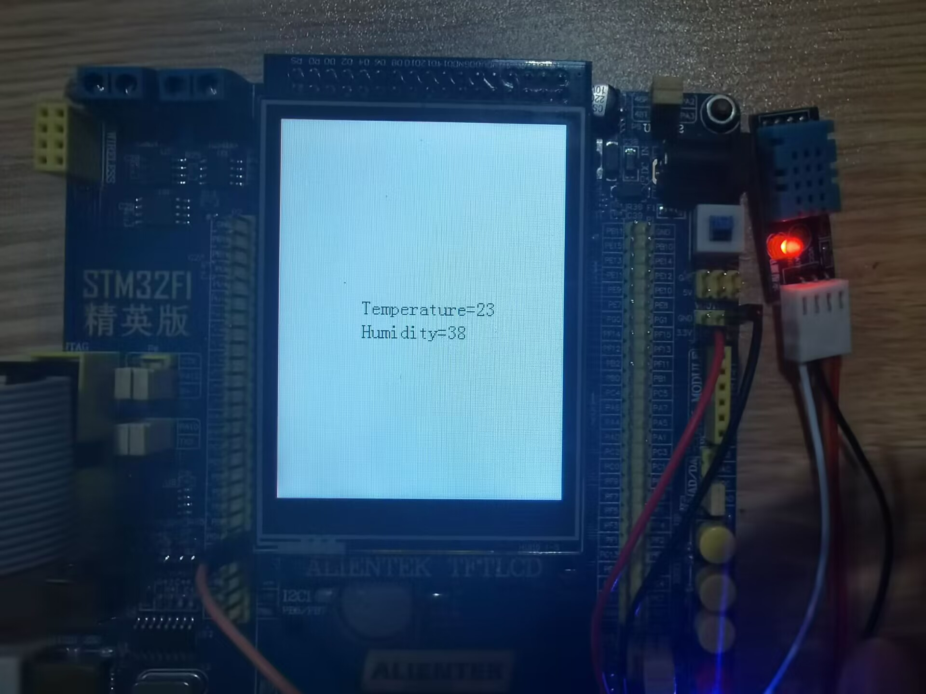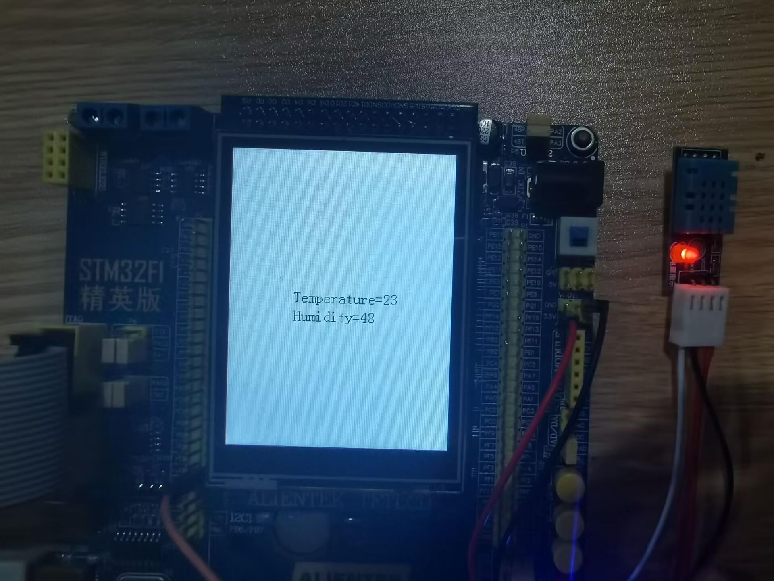

图一为初始的温湿度值，图二为吹口气后的温湿度值

注意事项：微秒级延时函数用到了通用定时器5。

**实验四 FreeRTOS系统中任务的实现**

**一．实验要求**

在FreeRTOS系统里实现实验1、实验2、实验3。

**二．实验目的**

熟悉FreeRTOS系统，了解系统的运行机制；掌握任务的建立，掌握任务间数据的交换。

**三．实验内容及步骤**

1、系统的工程的建立；

2、GPIO管脚的寄存器配置；

3、任务的创建。

**四．硬件结构电路图**

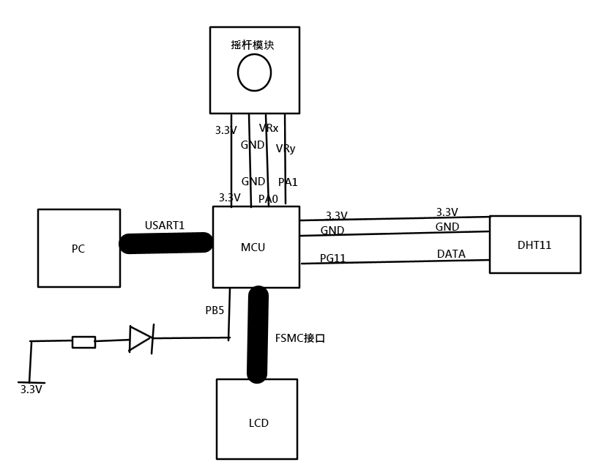

**五．实验设备**

1、硬件部分：计算机、STM32实验板。

2、软件部分：计算机windows系统；CubeIDE软件

**六．实验程序**

**1、给出主程序的流程图：**

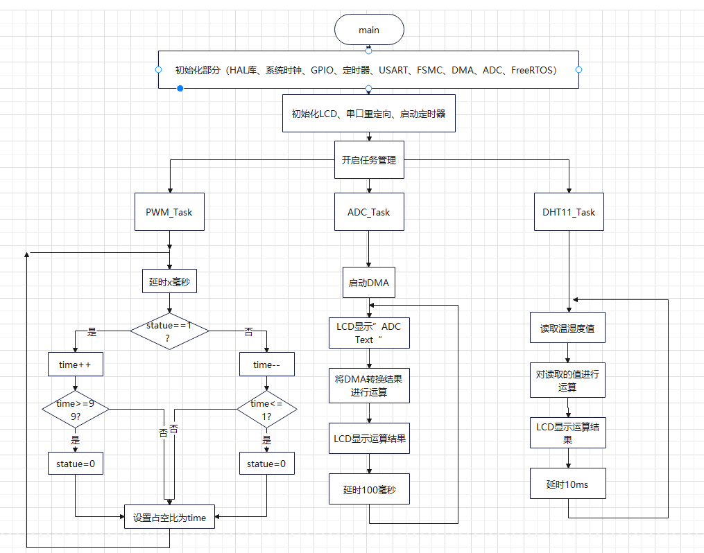

**2、程序代码：**

**（1）ｍａｉｎ函数**

1. int main(void)

2. {

3. HAL_Init();

4. SystemClock_Config();

5. MX_GPIO_Init();

6. MX_DMA_Init();

7. MX_USART1_UART_Init();

8. MX_FSMC_Init();

9. MX_TIM3_Init();

10. MX_TIM5_Init();

11. MX_ADC1_Init();

12. MX_ADC2_Init();

13. HAL_TIM_Base_Start(&htim5);

14. HAL_TIM_PWM_Start(&htim3, TIM_CHANNEL_2);

15. LCD_Init();

16. LCD_DisplayOn();

17. LCD_Clear(WHITE);

18. HAL_GPIO_WritePin(LCD_BL_GPIO_Port, LCD_BL_Pin, 1);

19. RetargetInit(&huart1);

20. HAL_ADC_Start(&hadc1);

21. HAL_ADC_Start(&hadc2);

22. MX_FREERTOS_Init();

23. osKernelStart();

24. while (1)

25. {

26. }

27. }

28.

**（2）根任务的创建**

1. void MX_FREERTOS_Init(void) {

2. osThreadDef(PWM_Task, PWM_Task1, osPriorityNormal, 0, 128);

3. PWM_TaskHandle = osThreadCreate(osThread(PWM_Task), NULL);

4. osThreadDef(ADC_Task, ADC_Task2, osPriorityIdle, 0, 128);

5. ADC_TaskHandle = osThreadCreate(osThread(ADC_Task), NULL);

6. osThreadDef(DHT11_Task, DHT11_Task3, osPriorityIdle, 0, 128);

7. DHT11_TaskHandle = osThreadCreate(osThread(DHT11_Task), NULL);

8. }

**（3）PWM任务的实现：**

1. void PWM_Task1(void const * argument)

2. {

3. for(;;)

4. {

5. __HAL_TIM_SetCompare(&htim3, TIM_CHANNEL_2, timee);

6. osDelay(10);

7. switch(statue)

8. {

9. case 0:

10. if(++timee>=99)

11. statue=1;

12. break;

13. case 1:

14. if(--timee<=1)

15. statue=0;

16. break;

17. }

18. }

19. }

**（4）ADC任务的实现：**

1. void ADC_Task2(void const * argument)

2. {

3. for(;;)

4. {

5. if(HAL_ADC_PollForConversion(&hadc1,200)==HAL_OK)

6. {

7. val_x=HAL_ADC_GetValue(&hadc1);

8. Volt_x=3300*val_x;

9. Volt_x=Volt_x>>12;

10. }

11. if(HAL_ADC_PollForConversion(&hadc2,200)==HAL_OK)

12. {

13. val_y=HAL_ADC_GetValue(&hadc2);

14. Volt_y=3300*val_y;

15. Volt_y=Volt_y>>12;

16. }

17. printf("x:%dmv y:%dmv\r\n",Volt_x,Volt_y);

18. osDelay(500);

19. }

20. }

**（5）DHT11任务的实现：**

1. void DHT11_Task3(void const * argument)

2. {

3. uint8_t t=0;

4. uint8_t temperature;

5. uint8_t humidity;

6. for(;;)

7. {

8. if(t%10==0)

9. {

10. DHT11_Read_Data(&temperature,&humidity);

11. sprintf(str_x,"Temperature=%d \r\n",temperature);

12. sprintf(str_y,"Humidity=%d \r\n",humidity);

13. LCD_ShowString(70, 150, 200, 16, 16, str_x);

14. LCD_ShowString(70, 170, 200, 16, 16, str_y);

15. }

16. osDelay(10);

17. t++;

18. }

19. }

**六．程序调试及实验结果**

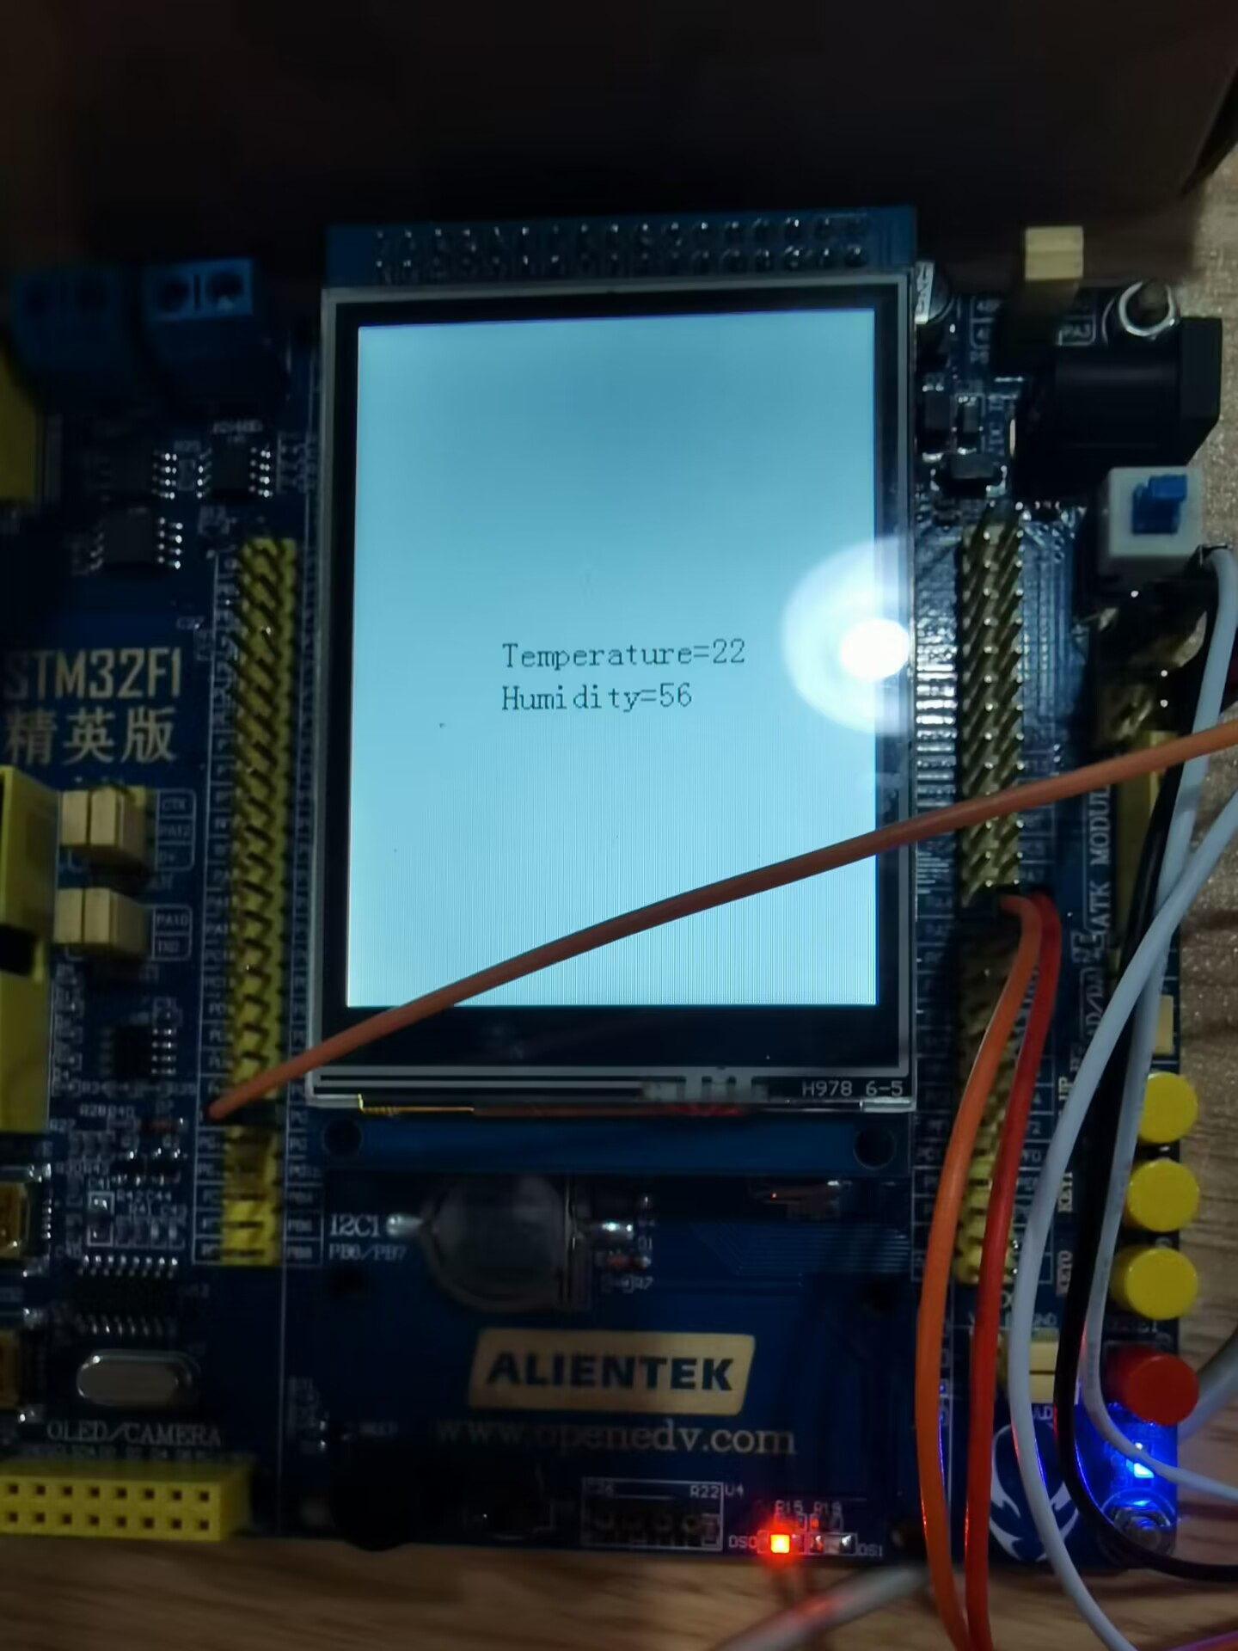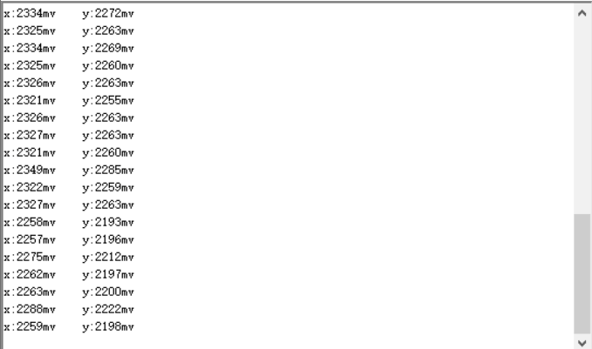

图一为ADC_Task，图二为PWM_Task以及DHT11_Task。

注意事项：微秒级延时函数用到了通用定时器5，操作系统中的延时函数用到了osDelay()。

|  |  |
| --- | --- |
| **学生实验 心得** | 在学习嵌入式的课程中，我掌握了很多嵌入式的思维以及开发方式。通过做着一次又一次的实验，调试一次又一次的bug，让我的代码水平得到了显著的提升。无论是从硬件连接还是软件配置，都让我觉得嵌入式是一门十分有趣的专业。我希望凭借自身的努力，在嵌入式这条道路上越走越远。  因为我很早之前就接触并使用CubeIDE进行程序的编写，对CubeIDE的掌握还算相对熟练，在本次嵌入式实验课以及往后的嵌入式开发之中，我将会更加强化对HAL库的掌握，也将更加了解底层寄存器的原理。同时，感谢各位学长耐心的给我测评，更感谢老师的谆谆教诲。  学生（签名）：  2022年12月10日 |
| **指导**  **教师**  **评语** | 成绩评定：  指导教师（签名）：  年 月 日 |